Zoom Guidance
COVD-19

Table of Contents
CONTEXT……………………………………………………………………………………………………… 3
SUMMARY OF KEY POINTS ..………………………………………………………………………… 3
GENERAL ADVICE ON VIDEO CALLING …………………………………………………………… 4
LOCKING A MEETING …………………………………………………………………………………… 4
STEP-BY-STEP GUIDE FOR SETTING UP YOUR ACCOUNT…………………………………. 5
SETTING UP AN ACCOUNT …………………………………………………………………………….. 5
LOGGING IN ………………………………………………………………………………………………….. 8
SETTING UP YOUR ONLINE MEETING ROOM ………………………………………………… 9
MAKING A CALL FROM A COMPUTER ………………………………………………………… 12
MAKING A ZOOM CALL FROM A MOBILE DEVICE ………………………………………. 14
SETTING UP A ZOOM STAFF MEETING ………………………………………………………. 15
USING THE ZOOM MEETING ROOM ………………………………………………………….... 15
SCHEDULING A MEETING WITHIN ZOOM ……………………………………………………. 17
USING MICROSOFT OUTLOOK FOR INVITATIONS/ACCESS TO ZOOM CONFERENCING…………………………………………………………………………………………… 18
PRIVACY SETTINGS ……………………………………………………………………………………… 19
SECURITY CHECK LIST ………………………………………………………………………………….

CONTEXT
In dealing with the COVID-19 pandemic, it is recognized that in continuing to deliver services, staff may need to consider new and innovative ways of working. With many staff now working remotely from home, the ability to utilize technological solutions for meetings and conferencing is being requested regularly. A practical guide for users and a security check list are set out below.

It must be emphasised that the use of Zoom is not endorsed by the GP Federation. This document sets out to ensure that users who are
using Zoom during the COVID-19 pandemic, maximise the security settings
available to them.

SUMMARY OF KEY POINTS
- ZOOM works via the internet on both organisations owned devices and home computers. It also works on personal smartphones via the ZOOM app

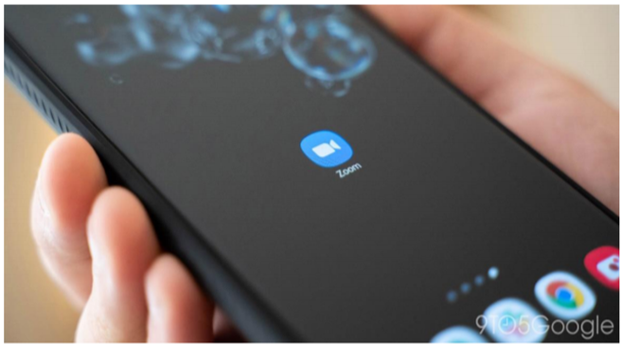

- If staff are using ZOOM from home, performance may sometimes be faster on a personal device e.g. personal smartphone.
- Service Users will not have access to your mobile phone number via ZOOM.
- For Service Users, they can join either from their personal computer/Mac, tablet or smartphone. If joining the call from a tablet or smartphone, they will have to download the ZOOM app.
- There are free and paid accounts. A free account will be sufficient for most users. The main limitation of a free account is that calls are limited to 40 mins. The call will automatically cut off after 40 mins but the call can be restarted.
- It is possible to schedule meetings in advance, or to invite users to join an online meeting room using an invite code.
- If using ZOOM to review Service Users, it is important in your initial set up to enable the waiting room feature (instructions below). This means that as a host, you can see someone is online and waiting to join the call. You then select a button to admit them to the video call. This is important to ensure that one Service User doesn’t join the video call of another Service User, e.g. if the earlier Service User’s appointment has overrun. This is important for protecting confidentiality.
- There is a facility to record calls within ZOOM. This should not be used by staff or Service Users. Service Users cannot record calls from the ZOOM app but may be able to do this from a home computer. Staff should be mindful of this possibility. If a Service User were to start recording a call, an alert will appear on the screen.
- ZOOM calls use a lot of mobile data and therefore users are advised not to use mobile data for these calls, but rather to use wifi/work internet, so as not to incur a charge in their mobile phone bill.

GENERAL ADVICE ON VIDEO CALLING
- For any call involving an under 18, it is essential that a parent/guardian is present for part of the call. This is for safe-guarding purposes and for the protection of both staff and Service Users.
- If the video call fails, it is important to have a back-up phone number for the Service User. Indeed, it may be helpful to phone the Service User initially and help them to join the ZOOM call.
- Remember to ensure no other Service Usernames/charts are visible on your video e.g. charts on your desk, to protect the confidentiality of others.
- Equipment. If using an organisation computer, you will require a webcam and microphone.
LOCKING A MEETING
1. At any time during a video conference the host can lock the
meeting, to ensure that no one else can access / enter the meeting. On the
live Zoom conference screen, click “Security”

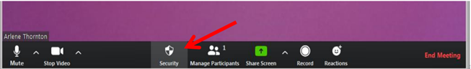

2. Then click “Lock Meeting”.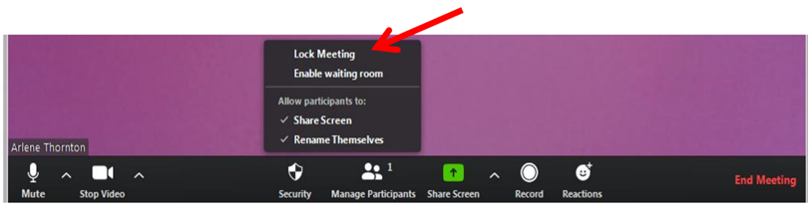

THIS MUST BE DONE ON EVERY MEETING

STEP-BY-STEP GUIDE FOR SETTING UP YOUR ACCOUNT
Setting up an account
- Go to the ZOOM website www.zoom.us
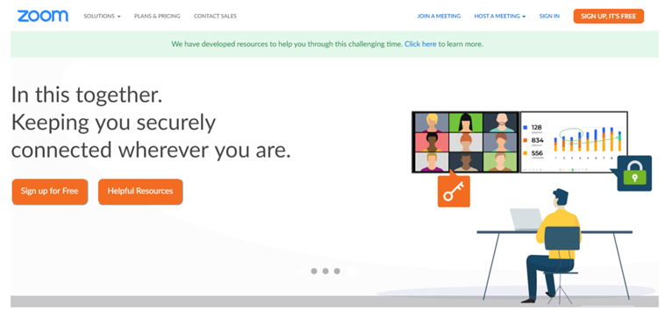

2. – Click “SIGN UP ITS FREE” (top right)
3. Type in your work email address and click “Sign Up” and an email will be sent to you. Access the Zoom email in your email Inbox.
4. Return to the Zoom website in your web browser and the following screen
appears:

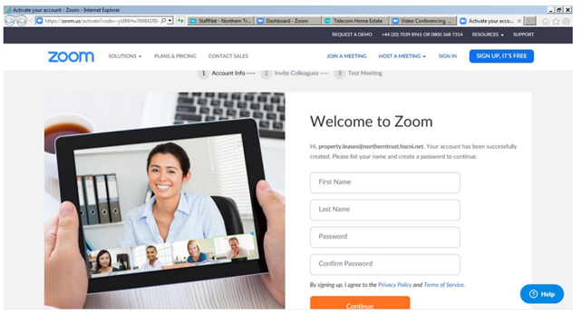
5. Enter your Zoom log in details as below following the password rules and that will be your Zoom account opened.

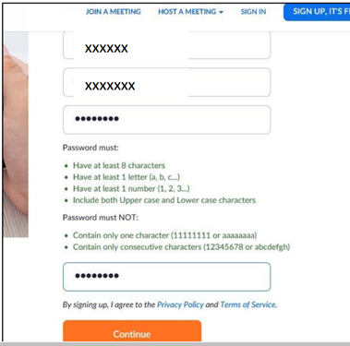

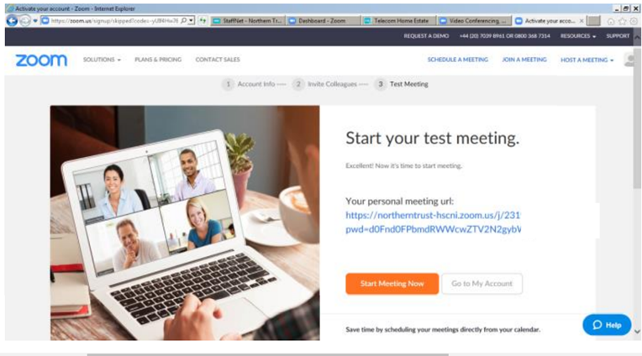

LOGGING IN

1. To log into ZOOM, type in www.zoom.us at your web browser address line as above and the Zoom home page appears. Click “SIGN IN”.
2. The following screen appears:
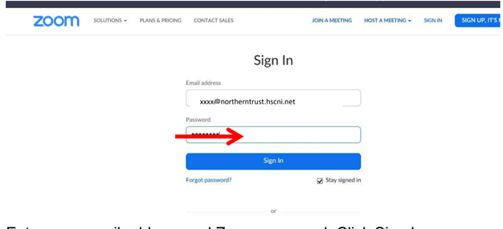
3. Enter your email address and Zoom password, Click Sign In.
SETTING UP YOUR ONLINE MEETING ROOM
This takes a bit of time but is helpful for ensuring you can invite users to join a video call in an easy way in future, and to enable your online waiting room, so that other Service Users do not inadvertently join someone else’s ZOOM appointment. You only need to do this before your first call. In future, these preferences will be your default.
1. Log in as above.
2. Depending on access, one of the two following screens will appear. If the first screen appears, Click “My Account” in the top right which will bring you to the second screen.

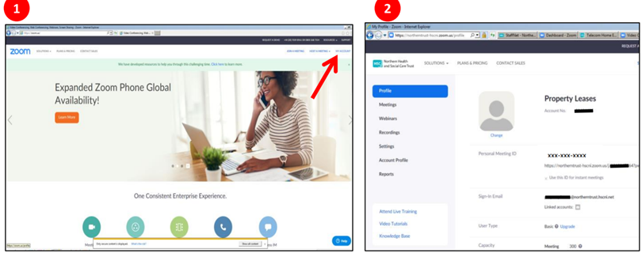

- Click “Meetings”

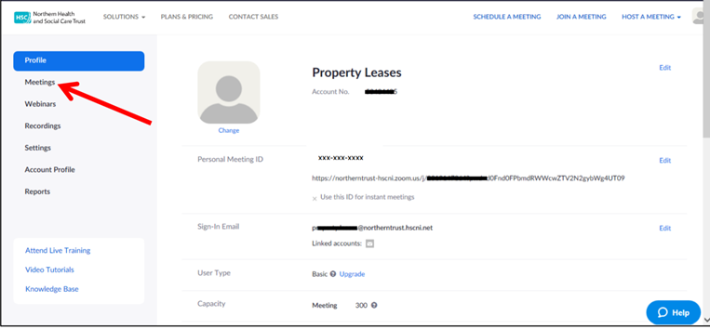

4. Check that ‘Meeting Password’ is checked, it should be by default on latest versions. This does not mean a password is required by the user to join
5. Click “Start a Meeting”.

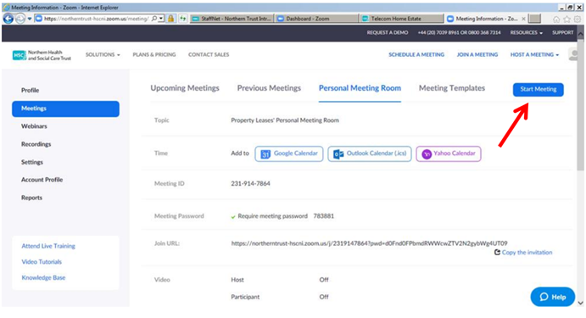

6. Write down your “Meeting ID”. You will need to give this to users to join your
calls.
7. Next is to adjust the settings for your meeting room. Scroll down and click
“Edit this Meeting” as shown below.

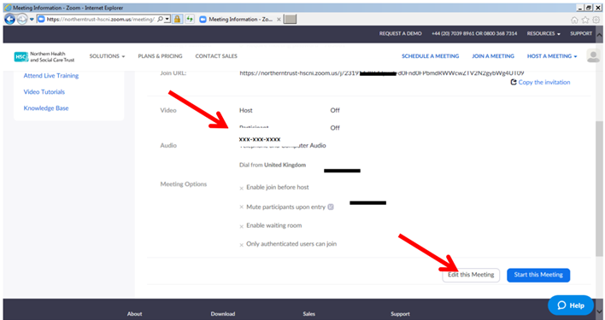

8. Turn OFF host and participant video, starting a meeting with video off avoids
any embarrassing moments: users will need to explicitly switch on video
sharing during the meeting. Click enable waiting room. This is important to
ensure that you are not interrupted by another person joining the call.

Please ensure the ‘Enable join before host’ is NOT selected.
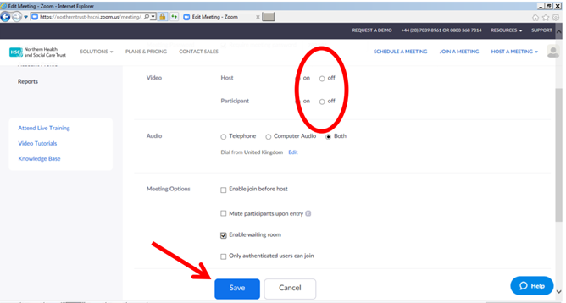

9. Then select “Save”

Always use the auto generation of meeting id’s rather than using the personal
meeting room option: every meeting will then have a different Meeting ID. If
one Meeting ID becomes compromised, then it will only apply to a single
meeting rather than every meeting you host.

MAKING A CALL FROM A COMPUTER
There are different ways to start a call in ZOOM. The method below involves some extra clicks but seems to be the easiest way to allow you to give a code over the phone to a Service User to join the call, and still allow you to keep the facility of a waiting room to avoid later Service Users joining the call before you are ready.
1. Follow steps 1-4 above, to get to the page about your personal meeting room.
2. Click “Start Meeting” in top right

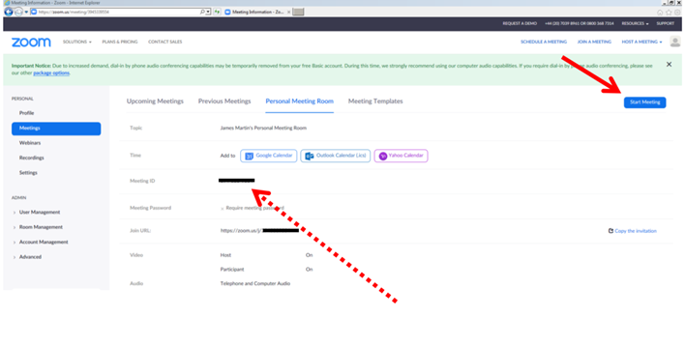
3. Call the Service User and give them your meeting ID (shown above in
previous step). (They enter this on the app after selecting the “Join a
Meeting” button.)
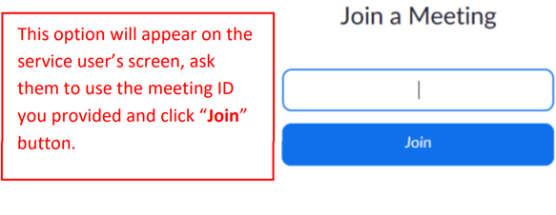

- Select “Run” when asked as shown below.

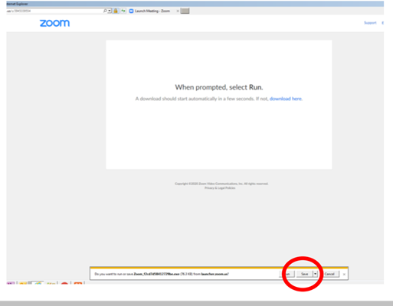

5. When the meeting screen opens on your computer, select “Join with
Computer Audio”
6. When the Service User is in the waiting room, you will receive a prompt at the bottom of the screen. To admit them to the call, click “Admit.”

7. To end the call, just select “End Meeting” at the bottom right.

MAKING A ZOOM CALL FROM A MOBILE DEVICE
***Important. Please note, the process below generates a unique meeting ID for each individual meeting, rather than the process above for the personal meeting room in which the meeting ID stays the same permanently.
1. Set up your account on a computer as above.
2. Download the ZOOM app.
3. Tap the “New Meeting” button
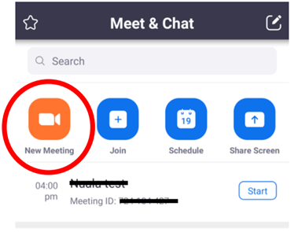
4. Select “Video On”.
5. Tap “Start a Meeting.” You may need to select the on-screen option “Call
using Internet Audio.”
6. To invite a Service User to join the call:
At the top of your call screen a long number will be displayed. This is the unique code for that meeting (it will be a different number for different meetings later in the day). Below this is a six-digit password (as pictured below). Give both these numbers to the Service User by phone.

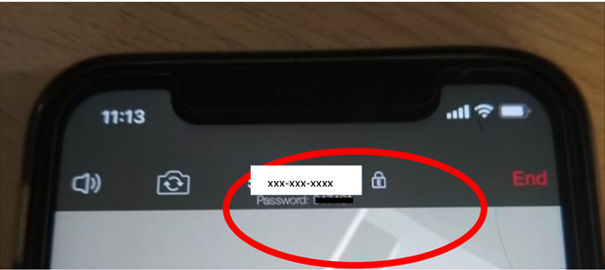

SETTING UP A ZOOM STAFF MEETING
The principles for a staff video meeting are the same as outlined previously. One staff member acts as the “host” for the meeting and other colleagues join the meeting as outlined previously for Service Users. There are at least two different ways to do this, as described below.

Using the ZOOM personal meeting room
An easy way to do this would be for the host to use their personal meeting room as outlined above in the section “Making a Call from Your Computer.” They would then give colleagues their meeting room ID (see step 3 in “Making a Call from Your Computer”) and arrange to join the meeting at the specified time.
Scheduling a meeting within ZOOM
An alternative is to set up a specific scheduled meeting.
1. Sign into ZOOM
2. Depending on access, one of the two following screens will appear. If the first screen appears, click “My Account” in the top right which will bring you to the second screen.
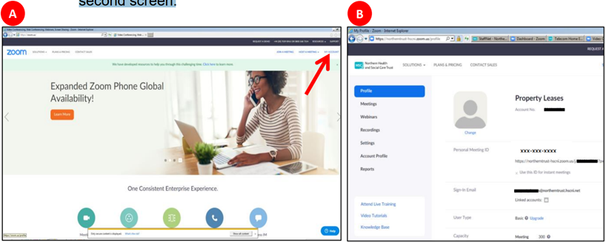

- Click “SCHEDULE A MEETING”

4. Fill in details such as the meeting date and time (shown below). If it is a
recurring meeting, you can tick that box.
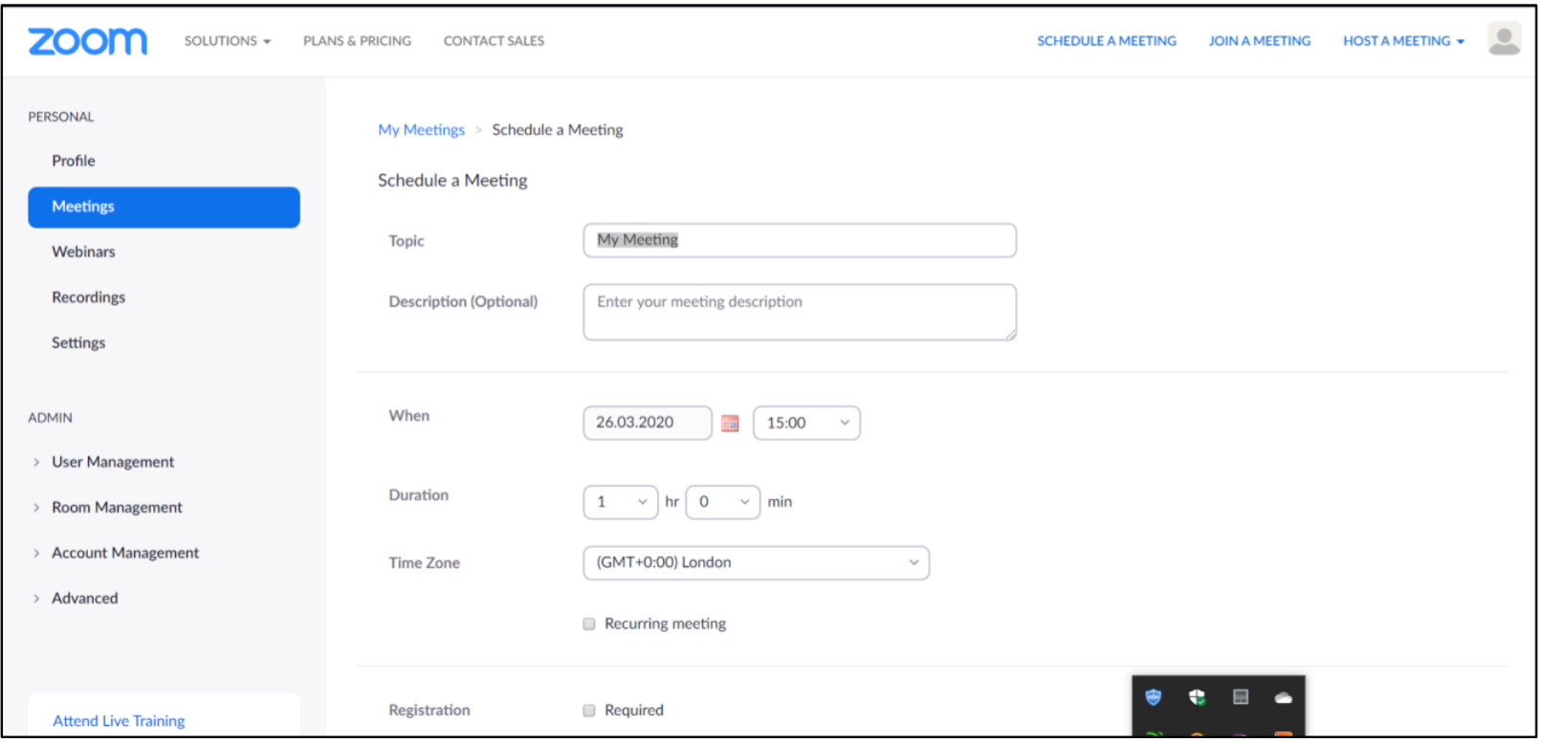
5. For a team meeting, you would still require a password to keep the meeting secure.
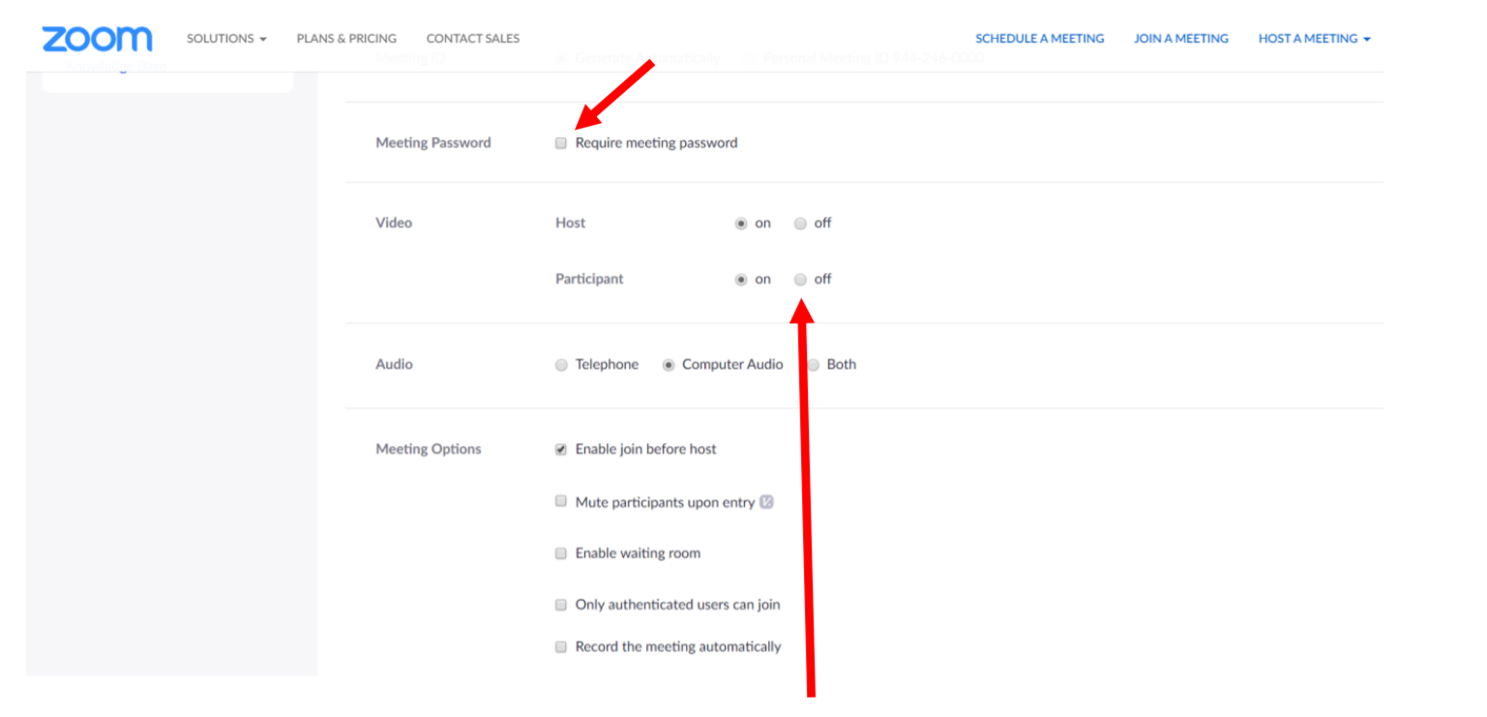
6. Tick video “off” for both host and participant.
7. Then scroll down and click “Save”
8. On the next screen, a Meeting ID will be displayed (as circled below). This is the number you give to colleagues to allow them to join the meeting.
To start the meeting at that point, you can click “Start the Meeting”
9. If the meeting is due to start at a later date, the following instructions are for how to find this meeting in future.
10. After logging in to ZOOM, click “MY ACCOUNT”, if applicable (as shown in step 2).
11.Then click on “Meetings”
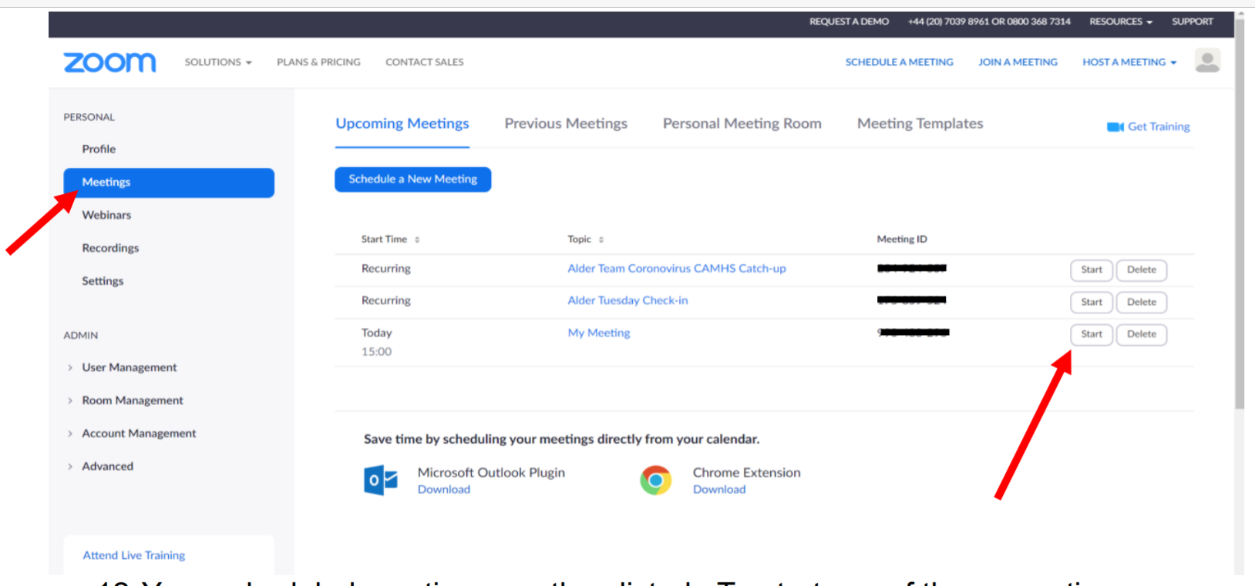

12.Your scheduled meetings are then listed. To start any of those meetings, select “Start” (these can be started at any time, not just at the designated start time). The meeting IDs for these are list as well, as a reminder of the number you must give others to join.

Using Microsoft Outlook for invitations/access to Zoom Conferencing
- After following steps 1 – 7 within the previous section (“Scheduling a meeting with Zoom”), click on “copy the invitation”.
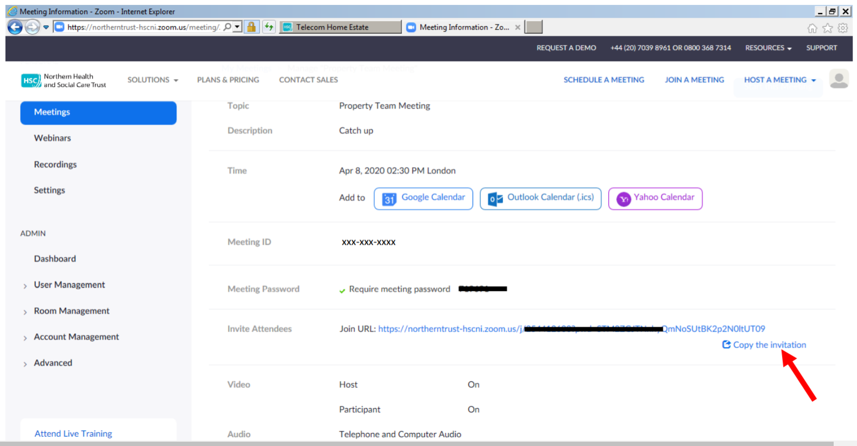

- Click “Copy Meeting Invitation”

- Click “Allow access” on the pop-up screen

- Open Microsoft Outlook, then create “New Message”, paste the details within the Message Field and add email addresses to those who are invited to attend the meeting. This will provide users to access the Zoom link (A) and the Meeting ID and password (B)

- This link can also be used via Outlook Calendar when arranging a “New Meeting” to invite attendees. This will provide users to access the Zoom link (A) and the Meeting ID and password (B)

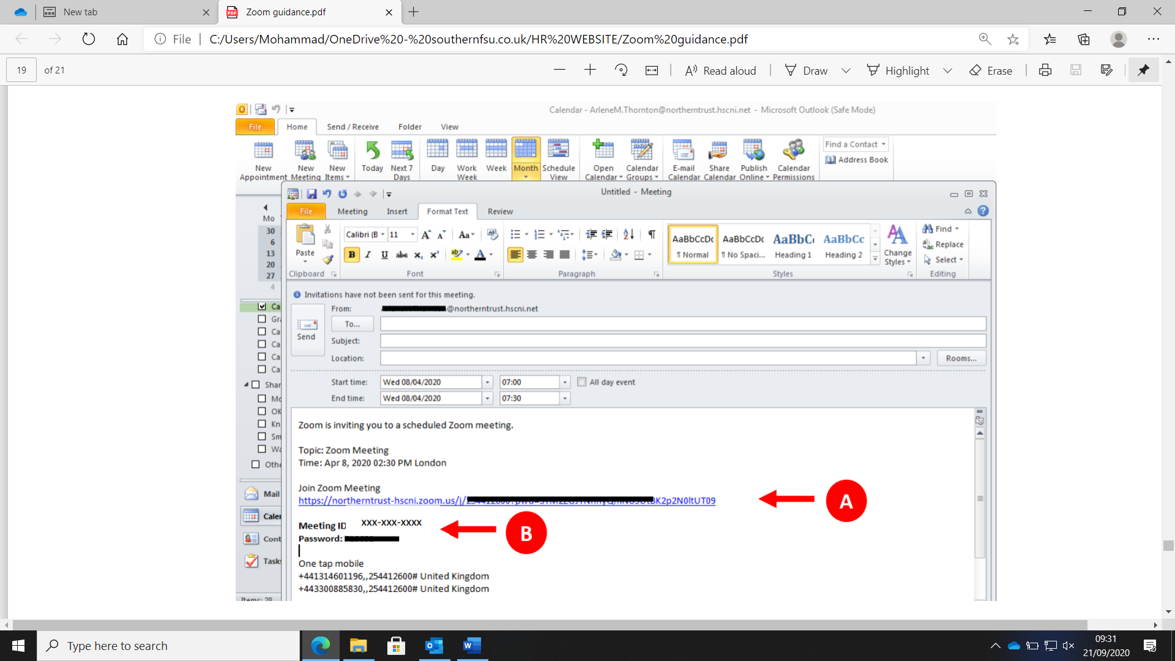

PRIVACY SETTINGS
To protect your privacy, we advise adjusting the cookie settings. To do this scroll to the bottom of the ZOOM home-screen and click “Cookie Preferences” as shown.
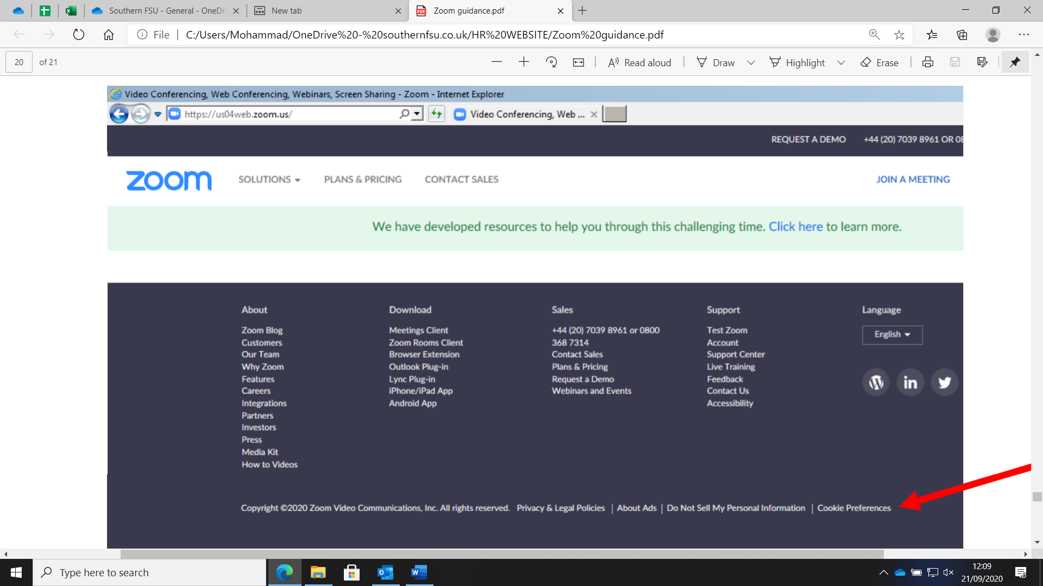

You can select your privacy preference. We suggest moving the slider to
“Functional Cookies.” Then click “Submit Preferences”

Security Check List

Auto generate meeting id
Ensure ‘require meeting password’ is selected
Turn OFF host and participant video
Mute participants upon entry
‘Enable join before host’ must never be selected.
Enable waiting room
Lock room once everyone is in

